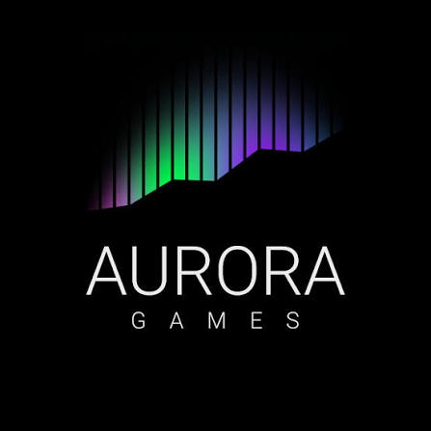
Aurora Games – Wheel of Fortune

Technical Documentation

1. Project Overview
Aurora Games – Wheel of Fortune is a console-based word guessing game developed in C++. The game is inspired by the classic Wheel of Fortune concept: players spin a wheel, guess letters, and attempt to reveal a hidden 7-letter word.

2. Game Rules

1. Players can only guess one letter at a time.
2. Each one of them spins the wheel before guessing to determine points or penalties.
3. If a players gets "+"
4. If a player gets "0", they lose their turn.
5. If a player guesses a letter that has already been revealed, they lose their turn.
6. Players can choose to guess the entire word at any time, but an incorrect guess results game loss.
7. The game ends when the entire word is revealed or a player correctly guesses the full word.

